
CI6280 – Threat Hunting, Analysis and Mitigation
Mohamud Elmi
K2121774
Splunk Log File Analysis and Visualisation


Table of Contents
1. Introduction 3
2. Technology Comparison 4
3. Results and Visualisation 6
3.1 Marriage in India Dataset 6
3.2 Diabetes Dataset 8
3.3 UFO Sightings Dataset 11
3.4 Tutorial Dataset 13
3.5 Global Traffic Dataset 15
4. Summary of Outcomes 19
5. Wow Factor 20
6. Conclusion 20
7. Video Demonstration Link 20
8. References 20

1. Introduction
This report details the implementation of Splunk for log file analysis and visualisation, tailored specifically for SoftAI International—a firm specialising in artificial intelligence solutions for mobile and IoT technologies. Recent expansions involving third-party network integrations have exposed the company to increased cybersecurity risks, particularly challenging given their lack of an internal cybersecurity team. My role as a Cyber Security Consultant involves deploying Splunk to effectively analyse and monitor network logs, thereby strengthening the company's security posture.
The project features analysis of five unique log datasets, each presented through customised Splunk dashboards. These dashboards highlight Splunk's powerful capabilities in real-time threat detection, monitoring network activities, and deriving operational insights. Ultimately, the deployment aims to equip SoftAI International with proactive tools to identify security threats, discern critical trends, and enhance their overall operational efficiency and market competitiveness.
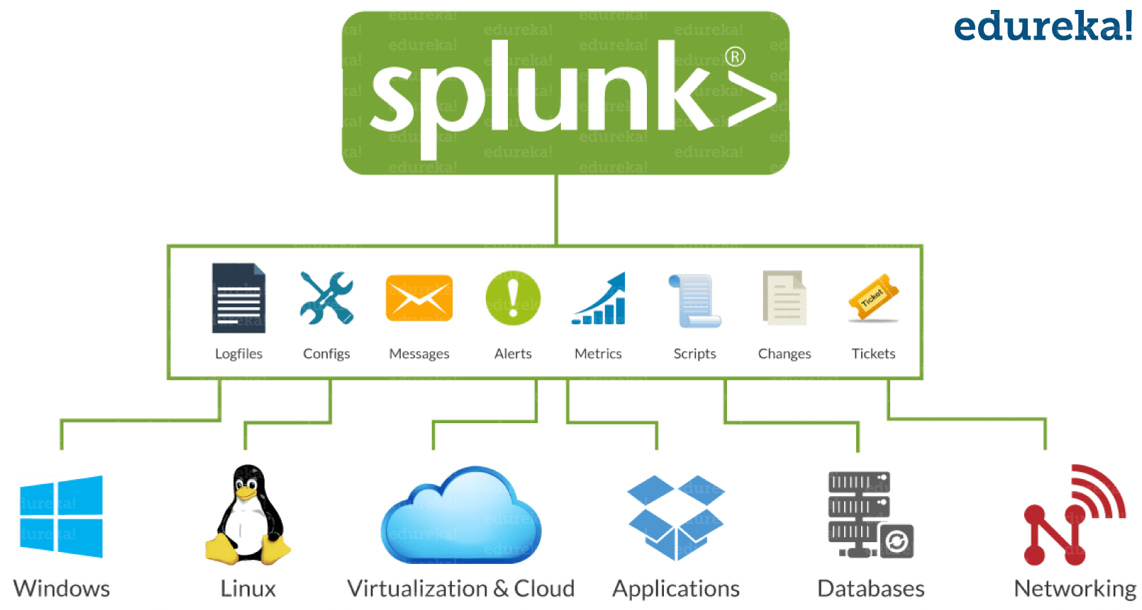

2. Technology Comparison
Criteria |  |  |  |  |  |  | Splunk |  |  |  |  | ELK Stack (Elasticsearch, Logstash, Kibana) |  |  |  |  |  |  |  | Graylog |  |  |  |  |  |  | IBM QRadar
Cost |  | Expensive commercial licensing; free tier available but limited |  |  |  |  |  |  |  | Open source; lower cost; enterprise support and scaling add extra expense |  |  | Open-source core with optional commercial features; generally, more cost‑effective |  |  |  |  |  |  |  |  | High cost; enterprise solution with licensing fees and support
Scalability | Highly scalable and enterprise‑grade; designed for very large, diverse datasets |  |  |  |  |  |  |  |  | Very scalable; horizontal scaling possible with distributed architecture |  |  |  | Scalable for small to medium deployments; may need extra tuning for very large datasets |  |  |  |  |  |  | Extremely scalable; built for large enterprises and high-volume security data
Ease of Use |  | User‑friendly interface and powerful Search Processing Language (SPL); learning curve for advanced features |  |  |  |  |  |  |  |  | Steeper learning curve; requires more configuration and customization; Kibana UI is powerful but less intuitive |  |  |  |  | Simpler UI than Splunk; fewer out‑of‑the‑box features but generally easier to set up |  |  |  |  |  |  |  | Complex interface and workflows; requires specialized training
Visualization |  | Rich, customizable dashboards with a wide variety of visualizations |  |  |  |  |  |  | Strong visualization capabilities with Kibana; highly customizable but may require additional setup |  |  |  |  |  |  |  | Basic visualizations and dashboards; functional but less polished than Splunk |  |  |  |  |  |  |  | Good built‑in visualizations; focused on security events rather than general data analytics
Data Ingestion |  |  | Supports a wide variety of data types; robust ingestion with flexible data parsing and indexing |  |  |  |  | Excellent data ingestion with Logstash and Beats; highly flexible and customizable |  |  |  |  |  |  | Effective data ingestion with built‑in pipelines; simpler configuration than ELK |  |  |  |  |  |  |  |  | Excellent integration for security logs and network data; optimized for SIEM data
Alerting & Monitoring |  |  |  | Advanced real‑time alerting and monitoring; integrated machine learning and anomaly detection (MLTK) |  |  |  |  | Alerting available but often relies on additional tools or custom configurations |  |  |  |  |  | Provides alerting capabilities; less advanced than Splunk’s integrated options |  |  |  |  |  |  |  | Comprehensive alerting and incident response capabilities; designed for security monitoring
Advanced Analytics / ML |  |  |  |  |  | Extensive support for advanced analytics and machine learning through add‑ons like Splunk MLTK |  |  |  | Limited built‑in ML; requires integration with external machine learning tools |  |  |  |  |  |  |  | Limited advanced analytics; primarily focused on log management and basic alerting |  |  |  |  |  | Advanced analytics and correlation capabilities tailored to security event analysis
Support & Community |  |  |  |  |  | Strong vendor support, extensive documentation, and a large active user community |  |  |  | Large and active open‑source community; commercial support available if needed |  |  |  |  | Smaller community compared to ELK and Splunk; available commercial support |  |  |  |  |  |  |  |  | Extensive vendor support and training; a smaller user community relative to open‑source solutions
Deployment & Maintenance |  |  |  |  | Straightforward deployment with robust enterprise support; resource‑intensive and may require dedicated hardware |  |  |  |  | More of a DIY solution, requires significant configuration and ongoing maintenance |  |  |  |  |  |  |  |  | Generally easier to deploy and maintain for small to medium environments |  |  |  |  |  |  | Enterprise‑level deployment; requires specialized skills and ongoing maintenance

3. Results and Visualisation
This section presents a series of custom Splunk queries applied to five distinct datasets. Each dataset is analysed using five queries that range from basic aggregations to more advanced analyses. The queries showcase a variety of Splunk functions—such as stats, eval, rex, and chart commands—resulting in diverse visualisations including bar charts, pie charts, scatter plots, line charts, and cluster maps. Through these visualisations, key insights and patterns are extracted from the raw data, demonstrating the effectiveness of the Splunk deployment in monitoring, analysing, and enhancing overall system security and performance.

3.1 Marriage in India Dataset
- Query 1: Total number of Marriages (single value)
This query calculates the overall number of marriage records in the dataset. It provides a clear snapshot of the dataset’s size, establishing the scale and scope of the analysis.
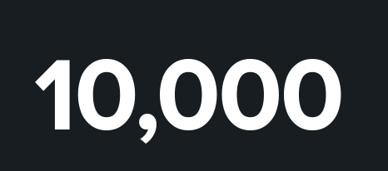
index=marriagedataset
| stats count as Total_Marriages
- Query 2: Distribution by Gender (pie chart)
This query breaks down the dataset by gender, showing the proportion of each group. It offers insights into the demographic balance, revealing whether there are significant differences in the number of male and female records.
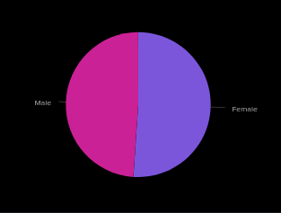
index=marriagedataset
| stats count by Gender
- Query 3: Distribution by Marriage Type (pie chart)
This query segments the data into different marriage types (love vs arranged). It highlights which type is more prevalent, offering a glimpse into cultural of societal preferences within the dataset.
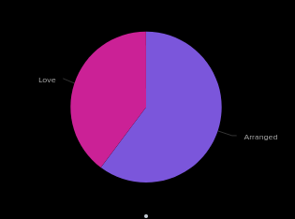
index="marriagedataset"
| stats count as Total_Count by Marriage_Type
- Query 4: Distribution by Caste Match (bar chart)
This query distinguishes between marriages occurring within the same caste and those occurring across different castes. It provides insights into social patterns and cultural practices, indicating how often traditional norms are followed or diverged from.
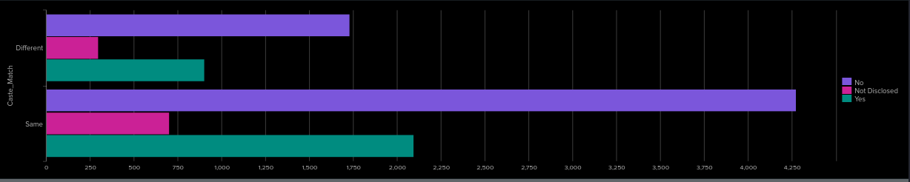
index="marriagedataset"
| chart count over Caste_Match by Dowry_Exchanged
- Query 5: Marital Satisfaction by Income Level (column chart)
This query examines marital satisfaction across various income brackets. It reveals potential correlations between financial status and relationship contentment, offering an understanding of how economic factors might influence marital happiness.
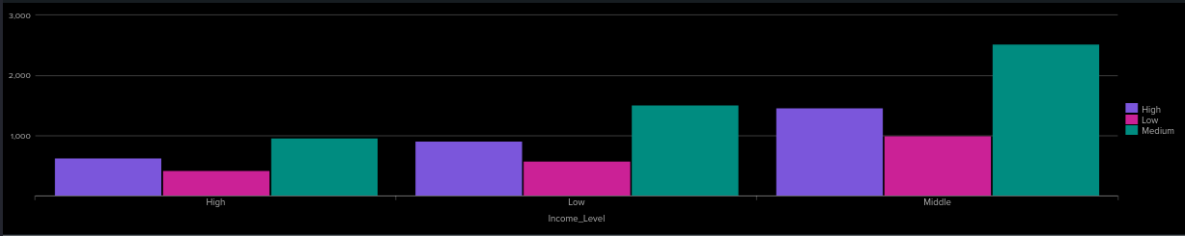
index=marriagedataset
| chart count over Income_Level by Marital_Satisfaction

3.2 Diabetes Dataset
- Query 1: Count of Patients with Diabetes vs. No Diabetes (pie chart)
This query calculates the total number of patients identified as having diabetes compared to those without the condition, providing a clear view of diabetes prevalence within the dataset.
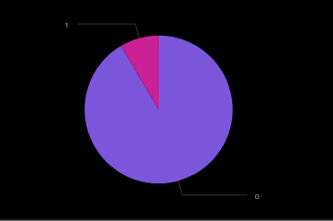
index=diabetesdataset
| stats count by diabetes
- Query 2: Average Blood Glucose Level by Gender (column chart)
This query computes the average blood glucose level for male and female patients separately, offering insights into potential gender differences in glucose readings.
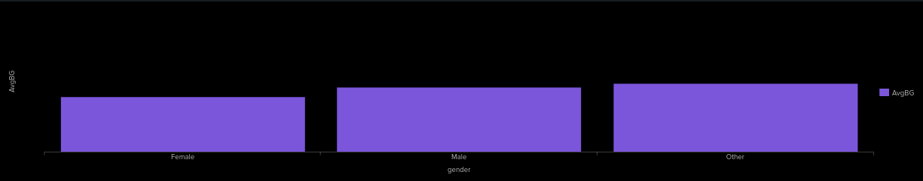
index=diabetesdataset
| eval BG = tonumber(blood_glucose_level)
| stats avg(BG) as AvgBG by gender
| eval AvgBG = round(AvgBG,1)
- Query 3: Distribution of BMI (bar chart)
This query groups patients based on their Body Mass Index (BMI), showing how BMI values are distributed across the population. It reveals common BMI ranges and highlights trends in patient weight categories.
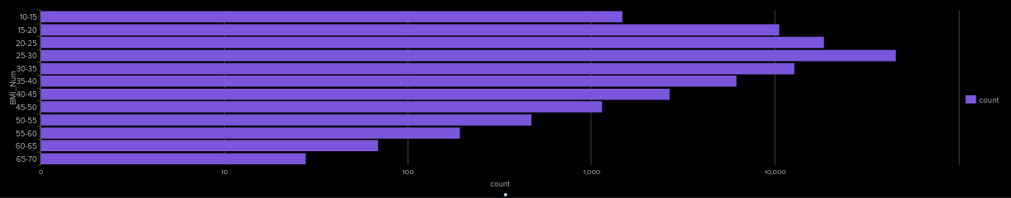
index=diabetesdataset
| eval BMI_Num = tonumber(bmi)
| bin BMI_Num span=5
| stats count by BMI_Num
| head 12
- Query 4: Blood Glucose vs HbA1c (scatter chart)
This query creates a scatter plot comparing individual blood glucose levels to HbA1c values. The visualisation explores the relationship between these two key diabetes indicators to determine if higher glucose levels correlate with elevated HbA1c readings.
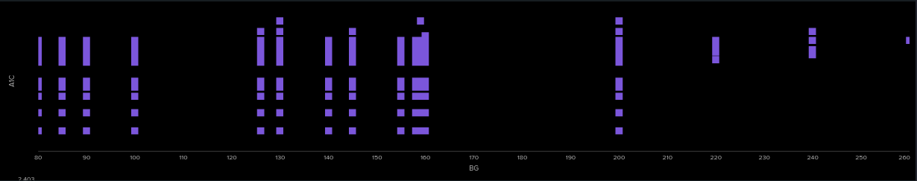
index=diabetesdataset
| eval BG = tonumber(blood_glucose_level)
| eval A1C = tonumber(hbA1c_level)
| table BG, A1C
| head 1000

- Query 5: Average Blood Glucose by BMI Bin (line chart, min value 100, max value 230)
This query divides patients into BMI ranges and calculates the average blood glucose levels within each bin. It highlights trends and potential associations between BMI and blood glucose levels across different patient groups.
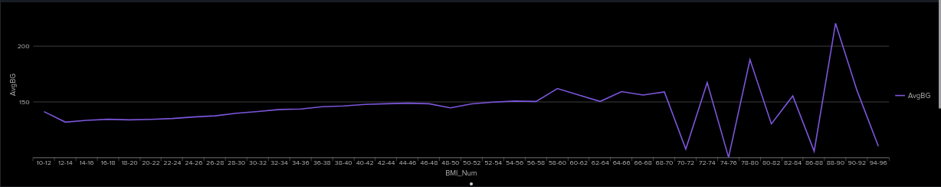
index=diabetesdataset
| eval BG = tonumber(blood_glucose_level), BMI_Num = tonumber(bmi)
| where isnotnull(BG) AND isnotnull(BMI_Num)
| bin BMI_Num span=2
| stats avg(BG) as AvgBG by BMI_Num
| eval AvgBG = round(AvgBG,1)

3.3 UFO Sightings Dataset
- Query 1: Monthly Distribution of UFO Shapes ( Bar chart)
This query aggregates UFO sighting data by month and categorises the sightings based on the shape of the UFO. It highlights seasonal trends and variations in the types of UFOs reported over the year.
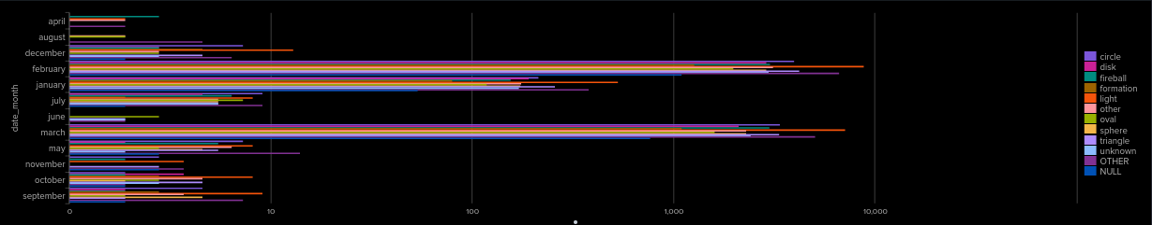
index=ufodatasets
| chart count over date_month by shape
- Query 2: Most Common UFO Shapes (Pie chart)
This query identifies the most frequently reported UFO shapes, revealing which forms are dominant in the dataset. It offers insights into recurring or popular shapes in UFO sightings.
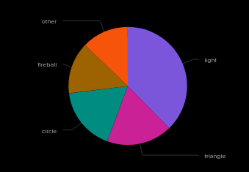
index=ufodatasets
| top shape limit=5 showcount=true showperc=true otherstr="Other Shapes"
- Query 3: Most Frequent Cities (bar chart)
This query determines which cities report the highest number of UFO sightings, providing a geographical perspective on where UFO activity is most prevalent.
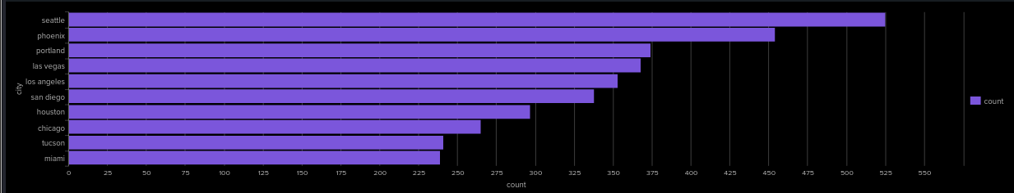
index=ufodatasets
- | top city limit=10 showcount=true showperc=true otherstr="Other Cities"
- Query 4: Average Duration of UFO Sightings (in Seconds) by Shape (bar chart)
This query calculates the average duration in seconds for UFO sightings grouped by shape. It helps determine whether certain UFO shapes are associated with longer or shorter sighting durations.
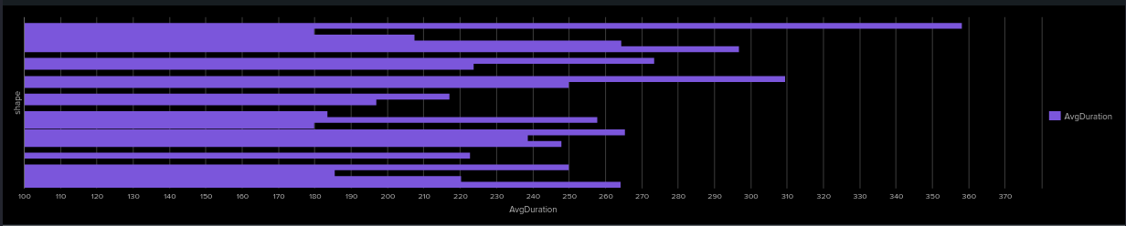
index=ufodatasets
| eval dur_text = 'duration _hours_min'
| rex field=dur_text "(?\d+(.\d+)?)"
| eval raw = tonumber(num)
| eval seconds = case(
match(dur_text, "(?i)minute"), raw * 60,
match(dur_text, "(?i)sec"), raw,
true(), raw
)
| where isnotnull(seconds)
| stats avg(seconds) as AvgDuration by shape
| eval AvgDuration = round(AvgDuration,1)
- Query 5: Cluster Map: Country-Level UFO Sightings (cluster map)
This query aggregates UFO sightings by country, mapping the results to show the geographical distribution on a world map. It highlights which countries have the highest number of sightings, offering a spatial overview of the phenomenon.
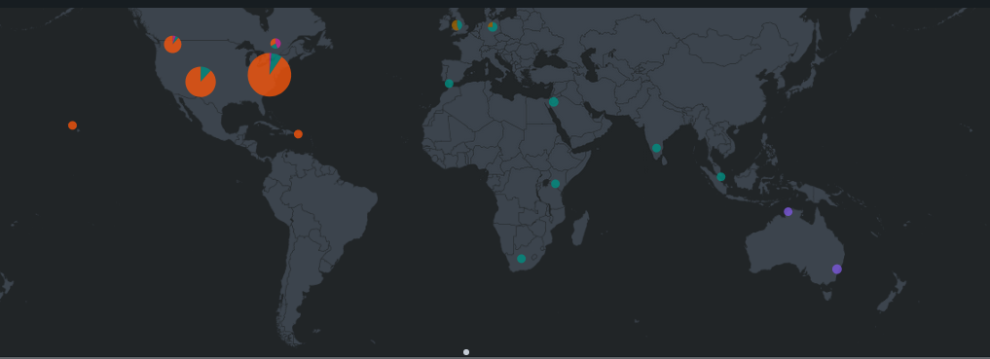
index=ufodatasets
| eval country_clean = if(isnull(country) OR country=="", "Other", country)
| eval country_full = case(
country_clean=="us", "United States",
country_clean=="ca", "Canada",
country_clean=="gb", "United Kingdom",
country_clean=="au", "Australia",
true(), "Other"
)
| geostats count latfield=latitude longfield=longitude by country_full

3.4 Tutorial Dataset

- Query 1: Rare File Usage
This query uses the rare command to identify the least frequently accessed files in your dataset. It helps highlight files that occur only a few times, which can indicate infrequent activity or potential anomalies in file logging.
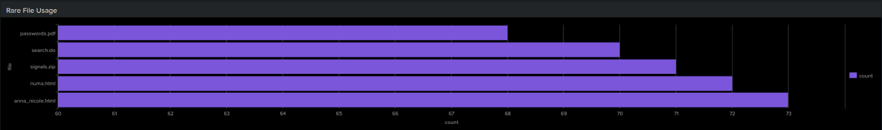
index="tutorialdata"
| rare file limit=5 showcount=true
- Query 2: Top Referrer Domains
This query applies the top command on the referer domain field to rank the external sources driving traffic. It shows the most common referer domains along with their counts and percentages, giving insight into where most traffic originates.
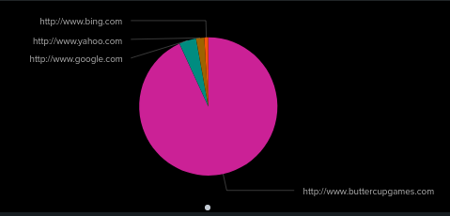
index="tutorialdata"
| top referer_domain limit=5 showcount=true showperc=true otherstr="Other Domains"
- Query 3: Unique Client IPs
By using the dedup command, this query isolates unique client IP addresses and then aggregates them by referrer domain. This approach provides a clear view of distinct visitors per referrer domain, which can be useful for understanding audience distribution.
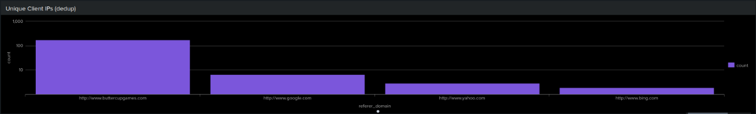
index="tutorialdata"
| dedup clientip
| stats count by referer_domain
| sort - count
- Query 4: Cumulative Daily Bytes
This query aggregates the total bytes transferred each day (using the date_mday field) and then calculates a running (cumulative) total using streamstats. The result shows how data usage builds up over the days, providing a trend of daily and cumulative network consumption.
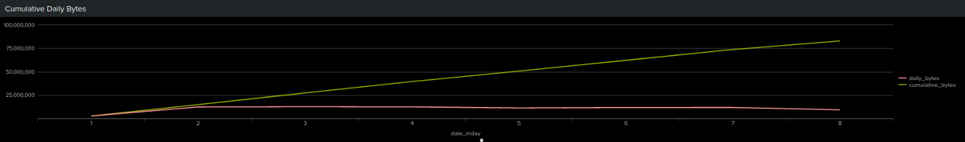index="tutorialdata"
| stats sum(bytes) as daily_bytes by date_mday
| sort date_mday
| streamstats sum(daily_bytes) as cumulative_bytes
| table date_mday daily_bytes cumulative_bytes

- Query 5: Top 20 Client IP Traffic
This query aggregates network traffic by client IP, calculating total bytes and event counts per IP. It then computes an average bytes-per-event metric and classifies each IP’s traffic level as “Heavy,” “Moderate,” or “Light.” Finally, it limits the results to the top 20 IPs, highlighting those responsible for the highest traffic volumes.
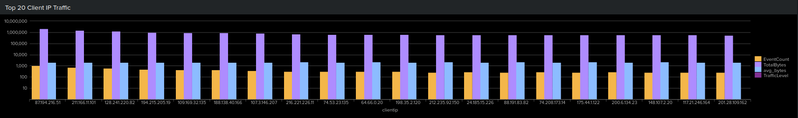
index="tutorialdata"
| stats sum(bytes) as TotalBytes, count as EventCount by clientip
| eval avg_bytes = round(TotalBytes / EventCount, 2)
| eval TrafficLevel = case(
avg_bytes > 10000, "Heavy",
avg_bytes > 5000, "Moderate",
avg_bytes <= 5000, "Light"
)
| sort – TotalBytes
| head 20
| table clientip, EventCount, TotalBytes, avg_bytes, TrafficLevel

3.5 Global Traffic Dataset
- Query 1:
This query groups accidents by the number of casualties, showing how frequently different casualty counts occur. It helps highlight whether accidents typically involve few or many victims and can guide further analysis into high-casualty events.
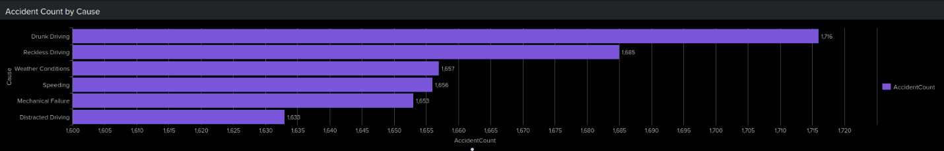
index="trafficdataset"
| stats count as AccidentCount by Cause
| sort - AccidentCount

- Query 2:
By aggregating accidents under each road condition (e.g., Wet, Snowy, Hail), this query reveals which conditions most often coincide with accidents. It provides insight into environmental factors contributing to higher accident rates.
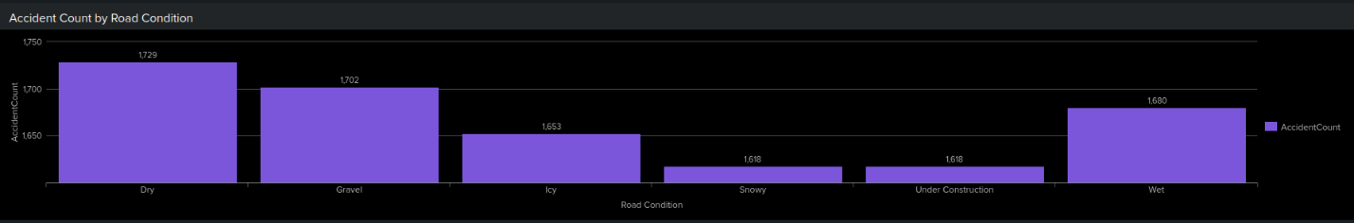
index="trafficdataset"
| chart count as AccidentCount by "Road Condition"

- Query 3:
This query breaks down accidents by the day of the week (e.g., Monday, Tuesday, etc.). It uncovers patterns in daily accident occurrence, indicating which days are riskier and potentially requiring more caution or preventative measures.
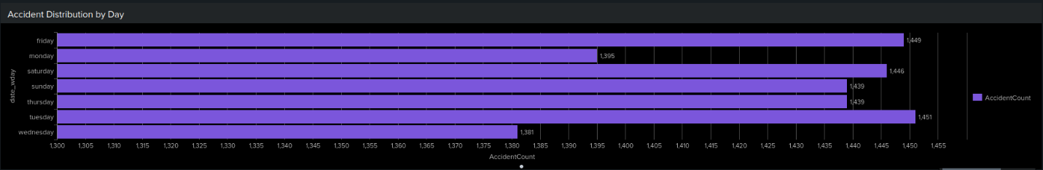
index="trafficdataset"
| stats count as AccidentCount by date_wday
| sort date_wday

- Query 4:
Displaying both daily accidents and a running cumulative total, this query captures the short-term fluctuations and the overall growth of accidents across the timeline. It’s valuable for detecting spikes and understanding long-term accident progression.
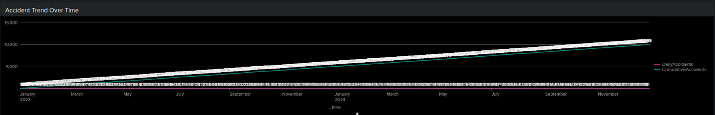
index="trafficdataset"
| eval _time = strptime(Date, "%Y-%m-%d")
| timechart span=1d count as DailyAccidents
| streamstats sum(DailyAccidents) as CumulativeAccidents
| table _time DailyAccidents CumulativeAccidents

- Query 5:
This query calculates the average casualties and total accidents per location, assigning each a High, Medium, or Low risk level. It pinpoints high-risk areas that may need targeted safety improvements or further investigation.
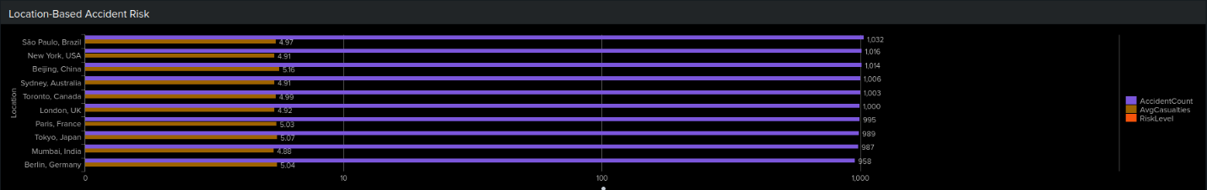
index="trafficdataset"
| eval casualties_num = tonumber(Casualties)
| stats avg(casualties_num) as AvgCasualties, count as AccidentCount by Location
| eval AvgCasualties = round(AvgCasualties,2)
| eval RiskLevel = case(
AvgCasualties >= 3, "High Risk",
AvgCasualties >= 1, "Medium Risk",
true(), "Low Risk"
)
| sort - AccidentCount
| table Location, AccidentCount, AvgCasualties, RiskLevel

4. Summary of Outcomes
The deployment of Splunk significantly impacts SoftAI International by enhancing the company’s capability to detect and respond promptly to cybersecurity threats. Real-time analysis and custom dashboards empower the company with a detailed overview of network activities, substantially improving threat visibility and response time. As a result, the company gains robust protection against vulnerabilities introduced through third-party integrations, crucial for maintaining operational continuity and reliability.

Additionally, Splunk's powerful analytical capabilities deliver actionable insights into network usage patterns and potential risks. By clearly visualising data trends and anomalies, SoftAI International can now make informed, strategic decisions aimed at optimising resources and improving efficiency. This strategic advantage allows the company to focus on innovation and market growth rather than reacting to security breaches.

Overall, the Splunk implementation positions SoftAI International as a more secure and competitive player in the AI services market. The actionable intelligence derived from detailed log analysis not only strengthens cybersecurity but also enhances operational performance, enabling the company to confidently pursue further integrations and expansions without compromising security.

5. Wow Factor
For the Wow Factor of this project, I addressed the challenge of analysing inconsistent and unstructured data using Splunk’s advanced core functionality. The UFO sightings dataset included a messy duration field (duration _hours_min) with diverse formats such as 'around 15 minutes', '3minutes', '20 seconds', '2 to 3 min', and '1hr +'. This made direct numerical analysis difficult and demanded a sophisticated approach to data cleaning.
index=ufodatasets
| eval dur_text = 'duration _hours_min'
| rex field=dur_text "(?\d+(.\d+)?)"
| eval raw = tonumber(num)
| eval seconds = case(
match(dur_text, "(?i)minute"), raw * 60,
match(dur_text, "(?i)sec"), raw,
true(), raw
)
| where isnotnull(seconds)
| stats avg(seconds) as AvgDuration by shape
| eval AvgDuration = round(AvgDuration,1)
Utilising the rex command with regular expressions, I extracted numerical values from the inconsistent textual entries. Subsequently, I applied conditional logic through the eval and case functions to convert all durations into a uniform unit of seconds, regardless of their original units. After standardising the data, I calculated the average duration for each UFO shape using stats avg, rounding the results for readability and clarity.
This comprehensive approach highlights Splunk’s capability in managing complex, real-world data, demonstrating its flexibility and power in extracting, cleaning, and transforming data into actionable insights. The final bar chart visualisation provided clear insights into average UFO sighting durations, effectively showcasing the practical value of advanced log analysis techniques.

6. Conclusion
In conclusion, the implementation of Splunk at SoftAI International has successfully addressed critical cybersecurity and data analysis needs, significantly enhancing operational efficiency and threat management capabilities. By delivering actionable insights and improving real-time monitoring, Splunk positions SoftAI International to better manage its expanding network integrations and cybersecurity risks.
The advanced data handling and visualisation capabilities demonstrated, particularly through the Wow Factor query, underscore Splunk's exceptional value in real-world scenarios. Splunk's flexibility in managing and analysing both structured and unstructured data allows SoftAI International to address various analytical challenges proactively. Furthermore, the real-time dashboards created during this project enable faster decision-making, improved resource allocation, and enhanced strategic planning, which collectively contribute to stronger cybersecurity and operational efficiency.
Ultimately, Splunk not only elevates SoftAI's cybersecurity posture but also provides a competitive advantage through strategic insight and decision-making support. This project sets a strong foundation for ongoing improvements and innovations, ensuring SoftAI International remains agile and resilient in the evolving landscape of cybersecurity threats and market demands.

7. Video Demonstration Link
(Include the URL to your video demonstration here. For example:)
Video Link: Video Demonstration splunk.MP4

8. References
Splunk Inc. (2023) Splunk Enterprise Documentation. Available at: https://docs.splunk.com/Documentation/Splunk (Accessed: 25 March 2024).
Splunkbase (2023) Splunk Machine Learning Toolkit (MLTK). Available at: https://splunkbase.splunk.com/app/2890/ (Accessed: 25 March 2024).
Splunk Quick Reference Guide (2024) Splunk SPL Reference Guide. [pdf] Available at: Splunk official website. (Accessed: 25 March 2024).
Graylog Inc. (2023) Graylog Documentation. Available at: https://docs.graylog.org/ (Accessed: 25 March 2024).
Personal communication with Splunk community forums and technical support for troubleshooting and command optimisation (March 2024).
Splunk YouTube Channel (2023) Splunk Tutorials and Case Studies. Available at: https://www.youtube.com/@Splunk (Accessed: 25 March 2024).
Harvard University (2023) Harvard referencing guide. Available at: https://www.citethisforme.com/harvard-referencing (Accessed: 25 March 2024).

